Solar Panel Power System Documentation

Components:

Solar Panel Power System

- 2 Solar Panels
- 1 SunSaver MPPT
- 2 DC to AC inverters
- 1 Dry-Cell 12V battery
- 1 Yellow Electrical Wire
- 2 Solar Panel Connectors with an open wire end
- 2 Red Disconnecting Tools
- 2 Paired Loop End Battery Cables

Wireless System

- 2 Tripod towers
- 1 airMax BaseStation (90 degree antenna)
- 1 AirGrid M5 (receiver)
- 2 Power supplies with POE and LAN connections
- 2 4PAIR CAT5e cables

Other Components
1 Stanley FATMax cart
1 Stanley chest
2 Four wheel adjustable hand-trucks
1 Folding table
Tools (needle-nose pliers, screwdriver, pliers, wire cutters, wire strippers, , wrench, wire clamps, standard and metric wrenches)
Electrical tape (Black, red, green, yellow, white, blue)
Ethernet cables
2 Flashlights
Magnifying glass
Scissors
Cable clamps
2 D-Link Gigabyte 5-port Desktop Switches
1 D-Link Wireless G Access Point
Bungee cords
2 Stanley Power Strips
1 Digital Multimeter
1 Bi Sheng Interchangeable Manual Tool Set
1 Stanley Mini-Screwdriver Set
Sharpie Pens
1 D-Clamp Bungee chord
1 Sanyo Battery Recharger
1 SOLAR Battery Tester
3 3 AMP Circuit Breakers
1 30 ft. Measuring Tape
1 AC (cigarette lighter) to battery connector
1 Kill A WATT Watt Meter with plug-in
1 Shop Light
1 Pack of mini-Notebooks
1 Box of Pens

Installation of the Solar Panel Power System

BEFORE connecting the Solar Panel Power System, MARK the POSITIVE (+) BATTERY TERMINAL with RED TAPE.

A. Single Solar Panel Power System Installation

- Place 1 Solar Panel onto 1 of the 4-wheeled hand-trucks.

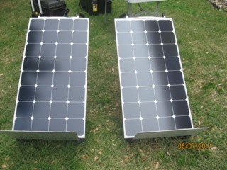Illustration 1: 2 Solar Panels are shown.

- Locate the NEGATIVE (-) and the POSITIVE (+) cable connectors on the back of the Solar Panel.
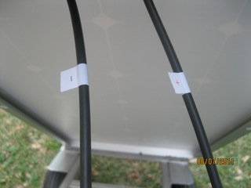Illustration 3: NEGATIVE (-) is on the LEFT. POSITIVE (+) is on the RIGHT.
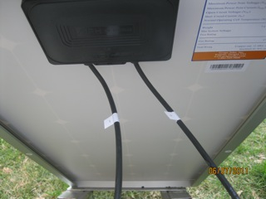Illustration 2: (NEGATIVE (-) is on the LEFT. POSITIVE (+) is on the RIGHT)

- Locate the 2 Solar Panel connectors that have a Solar Panel connector on one side and an open wire on the other. There are 2 of these in the FATMax.

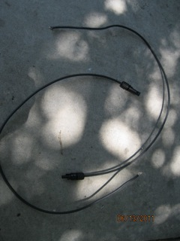Illustration 4: Solar panel connector and open wire.
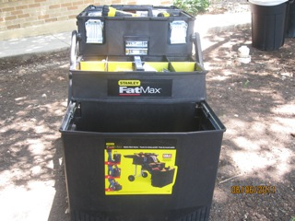Illustration 5: Stanley FatMax

- Connect the MALE open wire Solar Panel connector to the NEGATIVE (-) cable on the Solar Panel. This connection is the NEGATIVE (-).

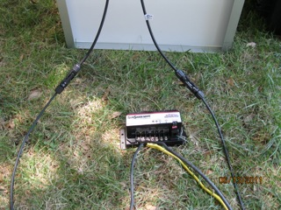Illustration 6: NEGATIVE (-) is on the LEFT. POSITIVE (+) is on the RIGHT.

- Connect the FEMALE open wire Solar Panel connector to the POSITIVE (+) cable on the Solar Panel. This connection is the POSITIVE (+). (See illustration above)

- Connect the NEGATIVE (-) open wire Solar Panel connector to the SunSaver Solar NEGATIVE (-) post using a screwdriver.
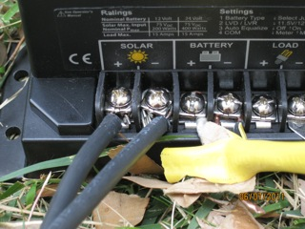Illustration 8: Solar panel connection is on the left. The battery post connections are also shown.

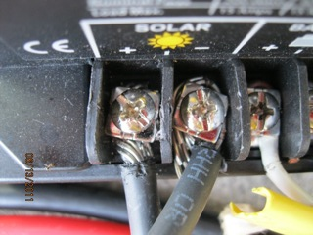Illustration 7: BOTH NEGATIVE (-) and POSITIVE (+) are shown connected.

- Connect the POSITIVE (+) open wire Solar Panel connector to the SunSaver Solar POSITIVE (+) post using a screwdriver. (See illustrations above)

- Locate the YELLOW electrical wire in the FATMax. Strip the wire on both ends as needed. After removing the YELLOW sheath from the internal wires there are 3 wires. The WHITE wire is the POSITIVE (+). The BLACK wire is the NEGATIVE (-). The GROUND wire (surrounded by paper) should be folded out of the way. Use needle-nose pliers to loop the ends of the YELLOW electrical cable.

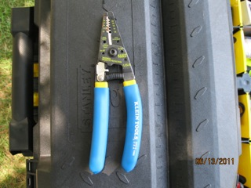Illustration 9: Wirestrippers
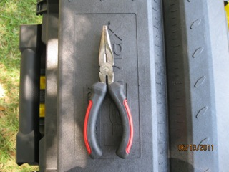Illustration 10: Needle-nose pliers
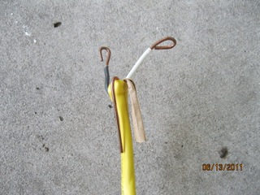Illustration 11: Stripped electrical wire with looped ends. Note that the ground wire is folded out of the way.

- Connect the NEGATIVE (-) BLACK electrical wire to the SunSaver BATTERY post using a screwdriver.

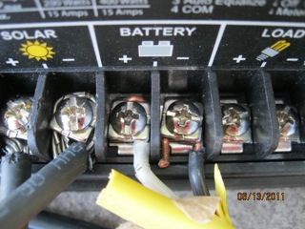Illustration 12: POSITIVE (+) is on the LEFT. NEGATIVE (-) is on the RIGHT.

- Connect the POSITIVE (+) WHITE electrical wire to the SunSaver BATTERY post using a screwdriver. (See illustration above).

- Locate 1 pair of LOOP END BATTERY CABLES. RED is POSTIVE. BLACK is NEGATIVE (-).
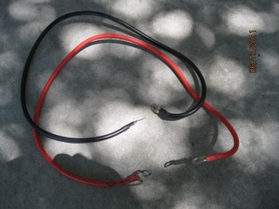Illustration 13: Looped-end battery cables. Note that the POSITIVE (+) and the NEGATIVE (-) are not connected to each other.

- Using a pair of needle nose pliers, loop the free end of the YELLOW electrical wire around 1 side of the connected BATTERY CABLES.
  - The WHITE POSITIVE (+) wire should be looped around the RED POSITIVE (+) BATTERY CABLE.
  - The BLACK NEGATIVE (-) wire should be looped around the BLACK NEGATIVE (-) BATTERY CABLE.

- Use electrical tape to wrap the POSITIVE (+) and NEGATIVE (-) connections separately.

- Use electrical tape to wrap both POSITIVE (+) and NEGATIVE (-) connections together.
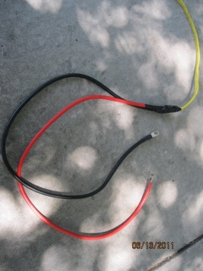Illustration 14: Steps 12-14.

- Place the free end of the connected BATTERY CABLES onto the battery.
  - The BLACK BATTERY CABLE is placed on the NEGATIVE (-) BATTERY POST.
  - The POSITIVE (+) BATTERY CABLE is place on the POSITIVE (+) BATTERY POST.
  - This connects the SunSaver to the BATTERY.

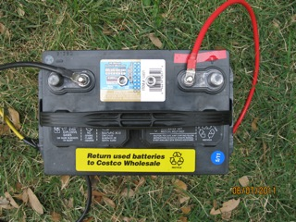Illustration 15: Note that the POSITIVE (+) BATTERY POST is clearly marked with RED TAPE.

- Locate the DC to AC inverter and the 1 PAIRED LOOP END BATTERY CABLES.
  - Place the NEGATIVE (-) inverter cable on the NEGATIVE (-) BATTERY POST.
  - Place the POSITIVE (+) inverter cable on the POSTIVE (+) BATTERY POST.
  - Place the NEGATIVE (-) loop end on the NEGATIVE (-) INVERTER POST.
  - Place the POSITIVE (+) loop end on the POSITIVE (+) INVERTER POST.

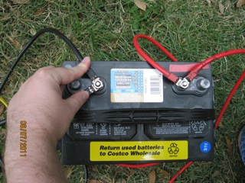Illustration 16: Note: The PAIRED LOOP END BATTERY CABLES from the SunSaver AND the INVERTER are connected onto the same BATTERY POSTS.
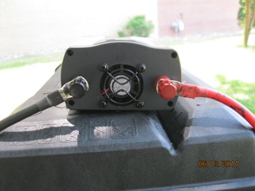Illustration 18: Looped-end battery cables connected from the battery to the inverter.
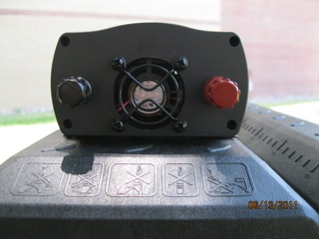Illustration 17: Inverter prior to installation of the looped-end battery cables.

- The Solar Panel Power System is now ready to turn on.

- Flip the power switch on the DC to AC inverter to on.

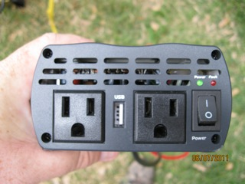Illustration 19: Power switch and LED indicator are shown. Note that there is also a USB connector.

B. Dual Solar Panel Power System Installation

- Place 1 Solar Panel onto each of the 4-wheeled hand-trucks and place them side-by-side.

Illustration 1: Solar panels on hand trucks.

- Locate the NEGATIVE (-) and the POSITIVE (+) cable connections on the back of each Solar Panel.

Illustration 2: NEGATIVE (-) is on the LEFT. POSITIVE (+) is on the RIGHT.

- Connect the POSITIVE (+) Solar Panel connector of the LEFT Solar Panel to the NEGATIVE (-)Solar Panel Connector of the RIGHT Solar Panel. This will bridge both Solar Panels.

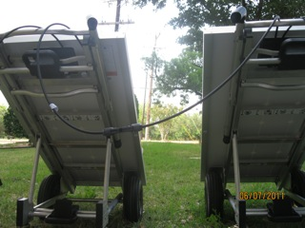Illustration 3: (POSITIVE (+) is on the RIGHT. NEGATIVE (-) is on the LEFT).

- Locate the 2 Solar Panel connectors that have a Solar Panel connector on one side and an open wire on the other. There are 2 of these in the FATMax.

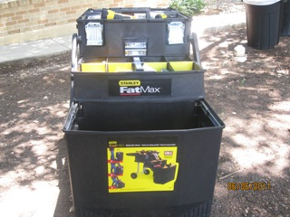Illustration 5: Stanely FATMax.
Illustration 4: Solar panel connectors with open wire ends.

- Connect the MALE open wire Solar Panel connector to the NEGATIVE (-) cable on the Solar Panel. This connection is the NEGATIVE (-).

Illustration 8: (NEGATIVE (-) is on the LEFT. POSITIVE (+) is on the RIGHT)
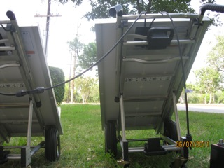Illustration 7: Note that the POSITIVE (+) connector of the LEFT panel is BRIDGED with the NEGATIVE (-) connector of the RIGHT panel.
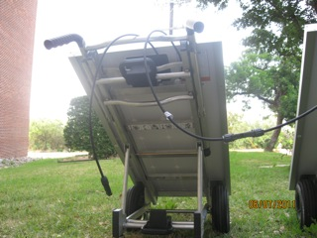Illustration 6: Bridged panels with an open NEGATIVE (-) connector.

- Connect the FEMALE open wire Solar Panel connector to the POSITIVE (+) cable on the Solar Panel. This connection is the POSITIVE (+). (See illustrations above)

- Connect the NEGATIVE (-) open wire Solar Panel connector to the SunSaver Solar NEGATIVE (-) post using a screwdriver.
Illustration 10: Solar panel connection is on the left. The battery post connections are also shown.

Illustration 9: BOTH NEGATIVE (-) and POSITIVE (+) are shown connected.

- Connect the POSITIVE (+) open wire Solar Panel connector to the SunSaver Solar POSITIVE (+) post using a screwdriver. (See illustrations above)

- Locate the YELLOW electrical wire in the FATMax. Strip the wire on both ends as needed. After removing the YELLOW sheath from the internal wires there are 3 wires. The WHITE wire is the POSITIVE (+). The BLACK wire is the NEGATIVE (-). The GROUND wire (surrounded by paper) should be folded out of the way. Use needle-nose pliers to loop the ends of the YELLOW electrical cable.

Illustration 11: Wirestrippers
Illustration 12: Needle-nose pliers
Illustration 13: Stripped electrical wire with looped ends. Note that the ground wire is folded out of the way.

- Connect the NEGATIVE (-) BLACK electrical wire to the SunSaver BATTERY post using a screwdriver.

Illustration 14: POSITIVE (+) is on the LEFT. NEGATIVE (-) is on the RIGHT.

- Connect the POSITIVE (+) WHITE electrical wire to the SunSaver BATTERY post using a screwdriver. (See illustration above).

- Locate 1 pair of LOOP END BATTERY CABLES. RED is POSTIVE. BLACK is NEGATIVE (-).
Illustration 15: Looped-end battery cables. Note that the POSITIVE (+) and the NEGATIVE (-) are not connected to each other.

- Using a pair of needle nose pliers, loop the free end of the YELLOW electrical wire around 1 side of the connected BATTERY CABLES.
  - The WHITE POSITIVE (+) wire should be looped around the RED POSITIVE (+) BATTERY CABLE.
  - The BLACK NEGATIVE (-) wire should be looped around the BLACK NEGATIVE (-) BATTERY CABLE.

- Use electrical tape to wrap the POSITIVE (+) and NEGATIVE (-) connections separately.

- Use electrical tape to wrap both POSITIVE (+) and NEGATIVE (-) connections together.
Illustration 16: Steps 13-15.

- Place the free end of the connected BATTERY CABLES onto the battery.
  - The BLACK BATTERY CABLE is placed on the NEGATIVE (-) BATTERY POST.
  - The POSITIVE (+) BATTERY CABLE is place on the POSITIVE (+) BATTERY POST.
  - This connects the SunSaver to the BATTERY.

Illustration 17: Note that the POSITIVE (+) BATTERY POST is clearly marked with RED TAPE.

- Locate the DC to AC inverter and the 1 PAIRED LOOP END BATTERY CABLES.
  - Place the NEGATIVE (-) inverter cable on the NEGATIVE (-) BATTERY POST.
  - Place the POSITIVE (+) inverter cable on the POSTIVE (+) BATTERY POST.
  - Place the NEGATIVE (-) loop end on the NEGATIVE (-) INVERTER POST.
  - Place the POSITIVE (+) loop end on the POSITIVE (+) INVERTER POST.

Illustration 18: Note: The PAIRED LOOP END BATTERY CABLES from the SunSaver AND the INVERTER are connected onto the same BATTERY POSTS.
Illustration 20: Looped-end battery cables connected from the battery to the inverter.
Illustration 19: Inverter prior to installation of the looped-end battery cables.

- The Solar Panel Power System is now ready to turn on.

- Flip the power switch on the DC to AC inverter to on.

Illustration 21: Power switch and LED indicator are shown. Note that there is also a USB connector.

